**User Guide of the MapMatching Program**

Please send your comments to [xzhou74@asu.edu](mailto:xzhou74@asu.edu) if you have any suggestions and questions.

1. **Data flow**

|  |  |
| --- | --- |
| **Input files** | **Output files** |
| node.csv | agent.csv |
| link.csv |
| input_agent.csv |
| trajectory.csv |

node.csv gives basic node information of the target network, including node_id, x_coord and y_coord.

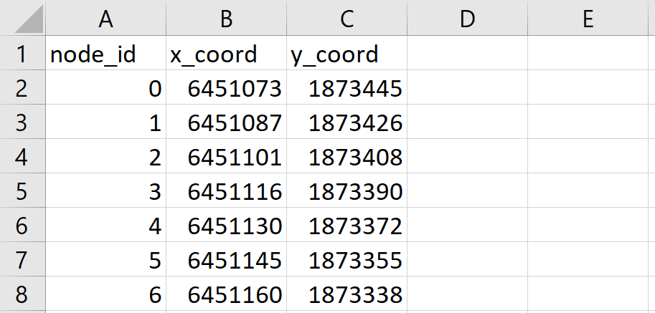

link.csv gives basic link information of the target network, including link_id, from_node_id and to_node_id. In the current version, a straight line is assumed to connect from node and to link of each link.

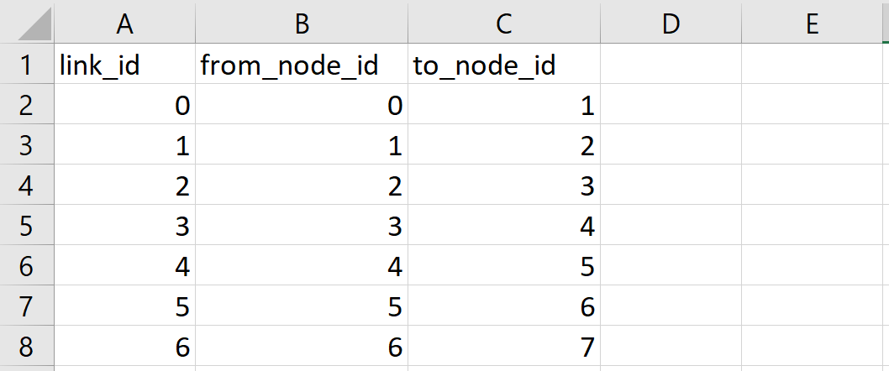

input_agent.csv gives the origin_node_id and destination_node_id of each agent.

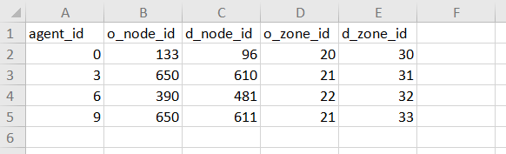

trajectory.csv gives trajectory location points of each agent. The timestamp format used here is hhmm:ss.

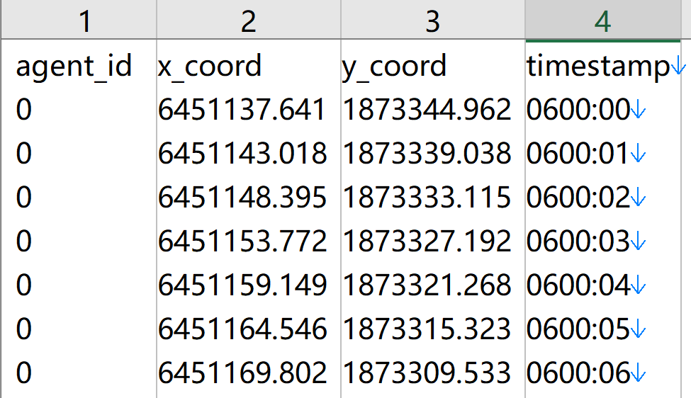

agent.csv is the output file of the program. A most-likely path is given for each agent based on input trajectories.

